
Symbiosis Institute of Technology, Pune
CSE- Academic Year 2026-27
Java Programming – Lab Batch 2025-29
Lab Assignment No.: 14
Name of Student | Akshit Gawade
PRN No. | 25070122029
Batch | 2025-2029
Class | A1
Academic Year & Semester | Second Year  Semester III
Date of Submission
Title of Assignment: | Write a Java program to demonstrate exception handling using try and catch blocks, nested and multiple try-catch blocks.
Problem Statement  &  Learning  Objective | Problem Statement  Write a Java program to demonstrate exception handling using try and catch blocks,  nested and multiple try-catch blocks.  Learning Objectives  To handle runtime exceptions using try-catch, nested try, and multiple catch blocks.
Theory | Exception handling prevents abnormal termination of programs due to runtime errors. The try block contains code that may generate exceptions, while catch blocks handle specific exceptions. Nested and multiple try-catch structures allow complex error management. Exception handling improves  software reliability and user experience by gracefully managing unexpected situations.
Program Code | Main1: (0 case)  public class Main1 {  public static void main (String[] args) {  int num1 = 10;  int num2 = 0;  try {  int result = num1 / num2;  System.out.println("Result : " + result);  } catch (ArithmeticException e) {  System.out.println("Error : Cannot divide by zero.");  System.out.println("Error : " + e.getMessage());  }  System.out.println("Program continues after exception handling.");  }  }  ------------------------------------------------------------------------------------------------------------  Main2: (Error Display)  public class Main2 {  public static void main (String[] args) {  try {  String str = "123a";  int num = Integer.parseInt(str);  int r = 10 / 0;  System.out.println(num + r);  } catch (NumberFormatException | ArithmeticException e) {  System.out.println("Error : " + e.getClass().getSimpleName() + " occured.");  }  }  }  --------------------------------------------------------------  Main3: (Divide by 0 case)  public class Main3 {  public static void main (String[] args) {  try {  System.out.println("Outer try block started");  try {  System.out.println("Inner try block started");  int result = 10 / 0;  System.out.println(result);  } catch (ArithmeticException e) {  System.out.println("Error + " + e.getMessage());  }  int result = 10 / 0;  System.out.println(result);  } catch (NullPointerException e) {  System.out.println("Caught NullPointerException in outer try block : " + e.getMessage());  } finally {  System.out.println("Finally block of outer try executed");  }  System.out.println("Program continues after nested try-catch blocks");  }  }
Output Screenshots | Main1:  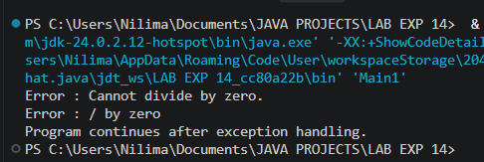  Main2:  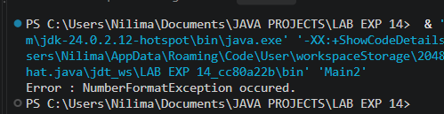  Main3:  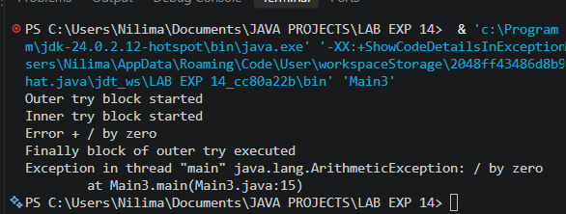
Exercise Qns  and Code | - Create an ATM program handling invalid withdrawal amount using try-catch  import java.util.Scanner;  public class Ex1 {  public static void main(String[] args) {  try (Scanner in = new Scanner(System.in)) {  double balance = 10000;  try {  System.out.print("Enter withdrawal amount: ");  double amount = in.nextDouble();  if (amount <= 0) {  throw new Exception("Invalid withdrawal amount!");  }  if (amount > balance) {  throw new Exception("Insufficient balance!");  }  balance -= amount;  System.out.println("Withdrawal Successful.");  System.out.println("Remaining Balance: Rs." + balance);  } catch (Exception e) {  System.out.println("Error: " + e.getMessage());  }  }  }  }  - Create an Online Shopping program that handles an invalid product quantity entered by the user using a try-catch block. Display an appropriate error message if the quantity is less than or equal to zero.  public class Exp2 {  public static void main (String[] args) {  int products = 10;  try (Scanner in = new Scanner(System.in)) {  try {  System.out.print("Enter number of products to but : ");  int am = in.nextInt();  if (am < 0) {  throw new Exception("Invalid Product Amount.");  }  if (am == 0) {  throw new Exception("Please enter amount more than 0.");  }  if (am > products) {  throw new Exception("Not enough products in stock to buy.");  }  System.out.println("Purchased!");  products -= am;  System.out.println("Remaining Products : " + products);  } catch (Exception e) {  System.out.println("Error: " + e.getMessage());  }  }  }  }
Output Screenshots | Ex1:  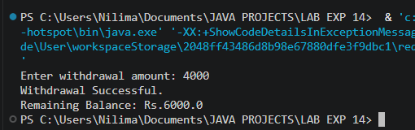  Ex2: (all cases)  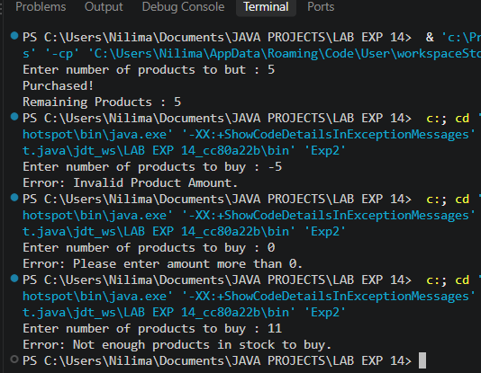
Conclusion | This experiment covers runtime error management to ensure program stability. By utilizing try-catch blocks and ordered multiple catch structures, it illustrates how to intercept specific runtime anomalies and prevent sudden program termination during invalid operational inputs.

